python查看显卡gpu信息

root@9c0aee92cfa5:~# python2 -m pip install nvidia-ml-py
root@9c0aee92cfa5:~# python2 -m pip list | grep nvidia
nvidia-ml-py 375.53.1

Pycharm + Docker开发模式
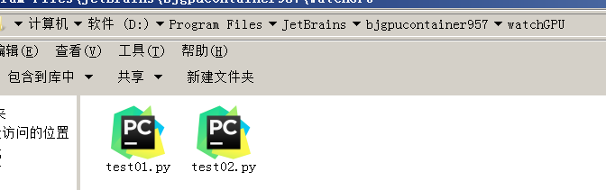
Test01.py
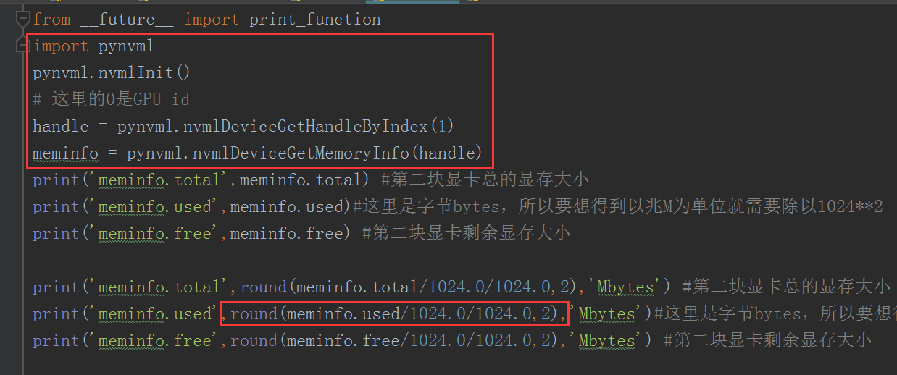
Run test01.py
sunfengzhen@gpu:~$ nvidia-smi -l
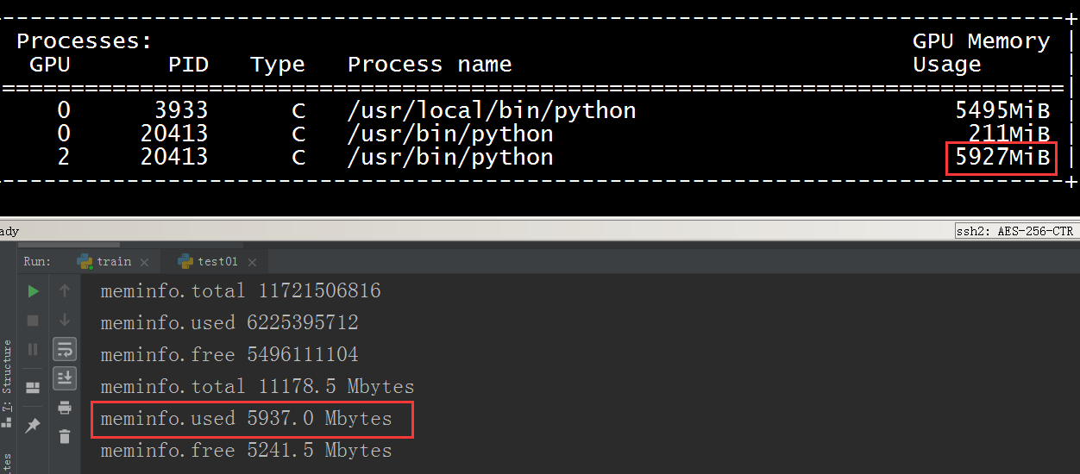
Test02.py
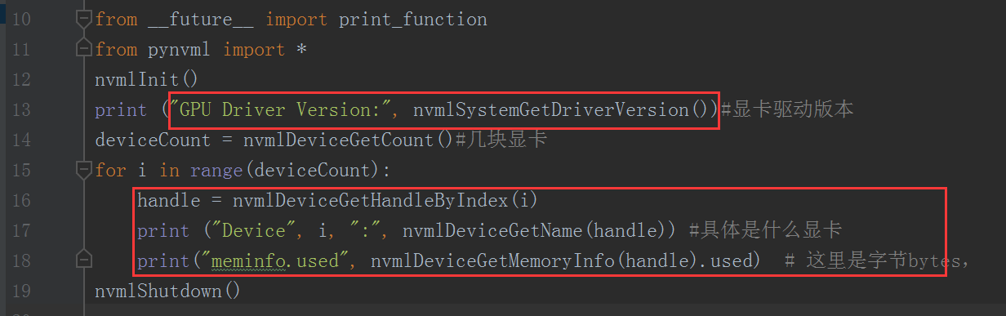
Run test02.py
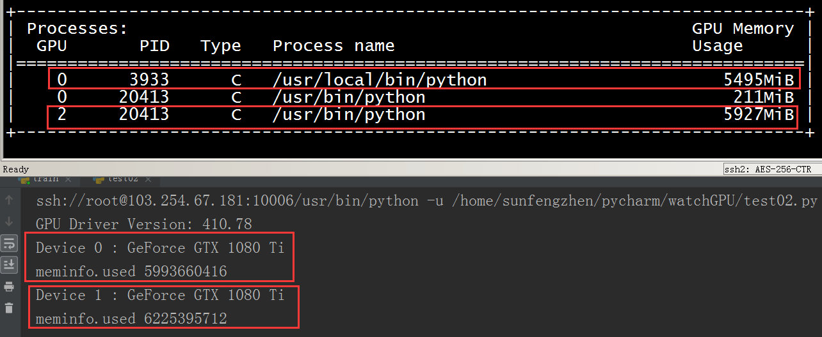

Device 0 对应0；Device 1对应2

参考：
https://blog.csdn.net/u013066730/article/details/82756379?tdsourcetag=s_pcqq_aiomsg
https://blog.csdn.net/u011094454/article/details/80774495
https://docs.nvidia.com/deploy/nvml-api/group__nvmlDeviceQueries.html#group__nvmlDeviceQueries_1g72710fb20f30f0c2725ce31579832654

